Robust clipped correlation: GBPUSD and USDCAD
Method 04 / daily log returns clipped at ±0.01, ±0.02, ±0.03 / Alpari D1 full available history

Study setup
Logical pair: GBPUSD , USDCAD
Broker symbols: GBPUSD_i , USDCAD_i
Snapshot: 2026-11-03_majors_alpari_D1
Timeframe: D1
Matched return window: 1999-01-05 to 2026-11-02 (UTC bar dates)
Matched return count n: 7205
Dropped unfinished last bar dated 2026-11-03 UTC after a tick-volume check against the prior complete day.
Clip bounds c in log-return units: 0.01, 0.02, 0.03 (about ±1%, ±2%, ±3% on the log scale). Headline c = 0.02.
Clipping caps a day's magnitude at ±c and keeps the row; it does not drop the day, so n is the same at every c.
Complete matched rows (Excel): GBPUSD-USDCAD_Clipped_D1.xlsx
Complete matched rows (HTML table): GBPUSD-USDCAD_Clipped_D1_data.html

Method carried forward
Each matched daily log return of close, ln(close_t / close_t-1), is clipped in the broker quote direction before Pearson correlation: x_tilde = min(c, max(-c, x)) and y_tilde = min(c, max(-c, y)), then rho_clip = Pearson(x_tilde, y_tilde) on the same rows as raw Pearson r. Quotes are not inverted. A day beyond ±c stays in the sample at the cap; n does not change. rho_clip is symmetric under swap of the two symbols. rho_clip = 0 means no straight-line link among the clipped values in this sample; it does not mean no link of any kind. The score is not a cause, not a lead, and not a trading signal. Daily rows are not independent draws, so the two-sided p-value and Fisher interval are reported and treated as secondary to rho_clip. Cap-hit counts (|log return| > c) flag how much of each leg was capped.

Raw Pearson on the same rows
Pearson r: -0.456462
Two-sided p-value: 0
Approximate 95% Fisher interval: [-0.474552, -0.437988]
This is the unclipped comparison required by the method. The headline score is rho_clip at c = 0.02 below.

Clipped results
n = 7205 at every c. Headline row is c = 0.02. Cap-hit count is the number of days with |log return| > c before clipping.
c | rho_clip | p | ci_low | ci_high | rho_minus_r | GBPUSD_cap_hits | USDCAD_cap_hits | GBPUSD_cap_share | USDCAD_cap_share
0.01 | -0.431983 | 0 | -0.45057968 | -0.4130118 | 0.024479301 | 511 | 404 | 0.070923 | 0.056072
0.02 | -0.451155 | 0 | -0.46935622 | -0.43257001 | 0.0053076872 | 39 | 32 | 0.005413 | 0.004441
0.03 | -0.45701 | 0 | -0.47508789 | -0.43854719 | -0.00054793241 | 11 | 3 | 0.001527 | 0.000416

Conclusion
Over 7205 matched daily log-return rows for GBPUSD and USDCAD (broker quote directions unchanged), headline robust clipped correlation at c=0.02 is -0.4512 (negative, moderate straight-line association among clipped values in this sample). Approximate 95% Fisher interval on the clipped series: [-0.4694, -0.4326]. Same-sample raw Pearson r is -0.4565 (rho_clip minus r = 0.0053). Sensitivity across the fixed grid: c=0.01 same sign; c=0.02 same sign; c=0.03 same sign. Two-sided p under the usual independent bivariate-normal model is 0; that model does not match linked daily FX returns, so treat p as secondary. This does not establish cause, lead-lag, or a lasting trading rule.

What to look at in this file next time
1) rho_clip at c = 0.02 versus raw Pearson r. 2) Whether c = 0.01 and c = 0.03 keep the same sign as 0.02. 3) Cap-hit counts before treating a large gap as settled. 4) The ±0.02 lines on the returns chart and the clip box on the scatter.

Charts
Daily closes

Daily log returns with +/- 0.02 clip lines
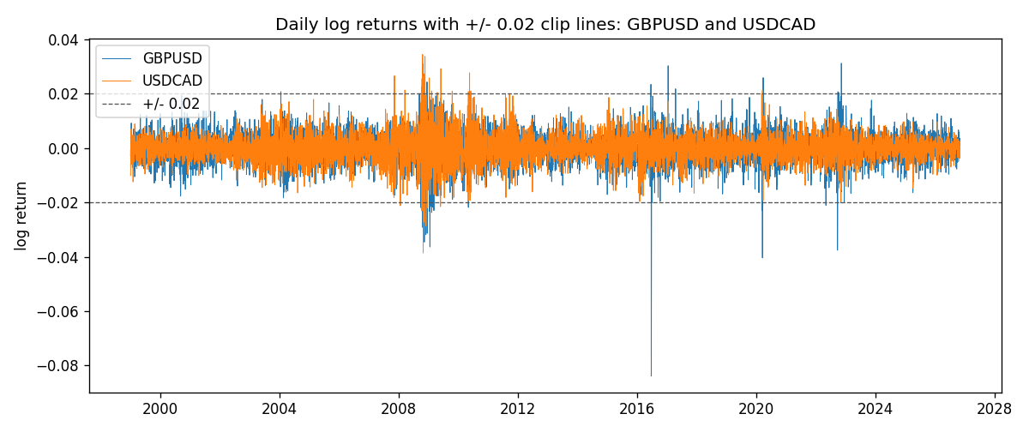
Log-return scatter with +/- 0.02 clip box
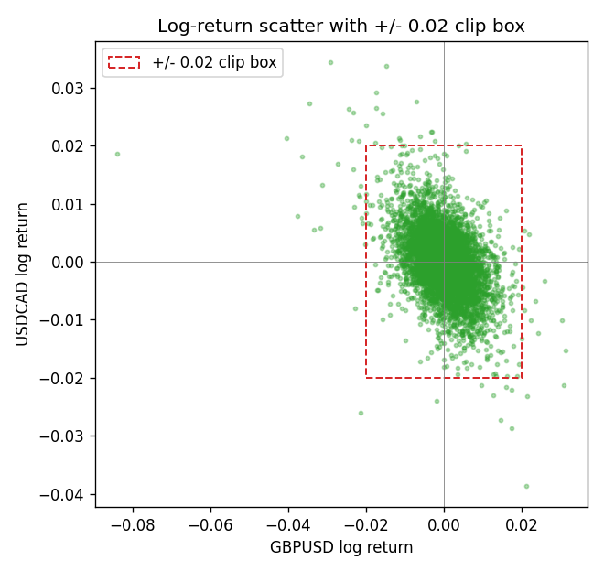

Data report
Every matched row that entered the clipped and raw correlations is stored in the sibling Excel workbook named GBPUSD-USDCAD_Clipped_D1.xlsx. That file is the complete data archive for redrawing charts. Embedding all rows as a Word table is impractical at this length; the Word file holds the column list, column summaries, and the first and last 15 matched rows.
Columns: time, GBPUSD_open, USDCAD_open, GBPUSD_high, USDCAD_high, GBPUSD_low, USDCAD_low, GBPUSD_close, USDCAD_close, GBPUSD_tick_volume, USDCAD_tick_volume, GBPUSD_spread, USDCAD_spread, GBPUSD_real_volume, USDCAD_real_volume, GBPUSD_log_return, USDCAD_log_return, GBPUSD_log_return_clip_0p01, USDCAD_log_return_clip_0p01, GBPUSD_log_return_clip_0p02, USDCAD_log_return_clip_0p02, GBPUSD_log_return_clip_0p03, USDCAD_log_return_clip_0p03
Column summaries (matched calculation rows)
column | count | mean | std | min | 25% | 50% | 75% | max
GBPUSD_open | 7205 | 1.5161639 | 0.2182756 | 1.06854 | 1.32505 | 1.51142 | 1.63205 | 2.1066
USDCAD_open | 7205 | 1.2670469 | 0.16900802 | 0.9168 | 1.119 | 1.29857 | 1.3723 | 1.6183
GBPUSD_high | 7205 | 1.5224596 | 0.21884187 | 1.08366 | 1.32981 | 1.5182 | 1.6384 | 2.1161
USDCAD_high | 7205 | 1.2719479 | 0.16896591 | 0.9336 | 1.1234 | 1.30394 | 1.3769 | 1.619
GBPUSD_low | 7205 | 1.5098441 | 0.21750249 | 1.03518 | 1.31956 | 1.50336 | 1.62444 | 2.0983
USDCAD_low | 7205 | 1.2624879 | 0.16904619 | 0.9056 | 1.1144 | 1.29361 | 1.36793 | 1.6102
GBPUSD_close | 7205 | 1.5162333 | 0.21823062 | 1.06879 | 1.3252 | 1.5114 | 1.6322 | 2.1065
USDCAD_close | 7205 | 1.2670655 | 0.16898286 | 0.916 | 1.11851 | 1.29871 | 1.37253 | 1.6137
GBPUSD_tick_volume | 7205 | 94776.836 | 153518.92 | 62 | 9986 | 52867 | 91739 | 1273370
USDCAD_tick_volume | 7205 | 80835.261 | 147176.39 | 37 | 5509 | 40849 | 71515 | 1410818
GBPUSD_spread | 7205 | 26.978348 | 19.192834 | 0 | 11 | 20 | 50 | 50
USDCAD_spread | 7205 | 23.508952 | 18.282466 | 0 | 9 | 17 | 40 | 60
GBPUSD_real_volume | 7205 | 3.5541156e+09 | 8.441481e+10 | 0 | 0 | 0 | 0 | 2.4038164e+12
USDCAD_real_volume | 7205 | 1.8330194e+10 | 9.6578305e+10 | 0 | 0 | 0 | 0 | 2.5751613e+12
GBPUSD_log_return | 7205 | -2.188e-05 | 0.00563988 | -0.08388241 | -0.00312535 | 3.221e-05 | 0.0031749 | 0.03112653
USDCAD_log_return | 7205 | -1.219e-05 | 0.00514402 | -0.03859748 | -0.00283601 | 4.92e-05 | 0.00272763 | 0.03436319
GBPUSD_log_return_clip_0p01 | 7205 | 1.636e-05 | 0.00484127 | -0.01 | -0.00312535 | 3.221e-05 | 0.0031749 | 0.01
USDCAD_log_return_clip_0p01 | 7205 | -3.182e-05 | 0.0044981 | -0.01 | -0.00283601 | 4.92e-05 | 0.00272763 | 0.01
GBPUSD_log_return_clip_0p02 | 7205 | 8.8e-07 | 0.00542343 | -0.02 | -0.00312535 | 3.221e-05 | 0.0031749 | 0.02
USDCAD_log_return_clip_0p02 | 7205 | -1.714e-05 | 0.00504468 | -0.02 | -0.00283601 | 4.92e-05 | 0.00272763 | 0.02
GBPUSD_log_return_clip_0p03 | 7205 | -9.76e-06 | 0.00553237 | -0.03 | -0.00312535 | 3.221e-05 | 0.0031749 | 0.03
USDCAD_log_return_clip_0p03 | 7205 | -1.211e-05 | 0.00512911 | -0.03 | -0.00283601 | 4.92e-05 | 0.00272763 | 0.03
First 15 matched rows (selected columns)
time | GBPUSD_close | USDCAD_close | GBPUSD_log_return | USDCAD_log_return | GBPUSD_log_return_clip_0p02 | USDCAD_log_return_clip_0p02
1999-01-05 | 1.6547 | 1.5123 | -0.0028966287 | -0.010131666 | -0.0028966287 | -0.010131666
1999-01-06 | 1.6537 | 1.5118 | -0.00060452184 | -0.0003306769 | -0.00060452184 | -0.0003306769
1999-01-07 | 1.6502 | 1.5141 | -0.002118709 | 0.0015202092 | -0.002118709 | 0.0015202092
1999-01-08 | 1.6405 | 1.511 | -0.0058954193 | -0.0020495197 | -0.0058954193 | -0.0020495197
1999-01-11 | 1.6312 | 1.5057 | -0.0056851331 | -0.0035137769 | -0.0056851331 | -0.0035137769
1999-01-12 | 1.6349 | 1.5157 | 0.0022657001 | 0.0066194721 | 0.0022657001 | 0.0066194721
1999-01-13 | 1.6499 | 1.5226 | 0.0091330396 | 0.0045420214 | 0.0091330396 | 0.0045420214
1999-01-14 | 1.6531 | 1.5332 | 0.0019376331 | 0.0069376546 | 0.0019376331 | 0.0069376546
1999-01-15 | 1.6502 | 1.5245 | -0.0017558204 | -0.0056905671 | -0.0017558204 | -0.0056905671
1999-01-18 | 1.6522 | 1.526 | 0.0012112405 | 0.00098344542 | 0.0012112405 | 0.00098344542
1999-01-19 | 1.6553 | 1.5302 | 0.0018745281 | 0.002748513 | 0.0018745281 | 0.002748513
1999-01-20 | 1.6472 | 1.5211 | -0.0049053846 | -0.0059646885 | -0.0049053846 | -0.0059646885
1999-01-21 | 1.6524 | 1.5146 | 0.0031518998 | -0.0042823796 | 0.0031518998 | -0.0042823796
1999-01-22 | 1.6565 | 1.5184 | 0.0024781662 | 0.0025057712 | 0.0024781662 | 0.0025057712
1999-01-25 | 1.6585 | 1.5197 | 0.0012066366 | 0.00085579808 | 0.0012066366 | 0.00085579808
Last 15 matched rows (selected columns)
time | GBPUSD_close | USDCAD_close | GBPUSD_log_return | USDCAD_log_return | GBPUSD_log_return_clip_0p02 | USDCAD_log_return_clip_0p02
2026-10-13 | 1.32534 | 1.4214 | 0.0036434319 | -0.0046395653 | 0.0036434319 | -0.0046395653
2026-10-14 | 1.31884 | 1.42356 | -0.0049164679 | 0.0015184751 | -0.0049164679 | 0.0015184751
2026-10-15 | 1.32757 | 1.41843 | 0.0065976411 | -0.0036101503 | 0.0065976411 | -0.0036101503
2026-10-16 | 1.33257 | 1.41357 | 0.0037592051 | -0.0034322068 | 0.0037592051 | -0.0034322068
2026-10-19 | 1.33024 | 1.41091 | -0.0017500314 | -0.0018835331 | -0.0017500314 | -0.0018835331
2026-10-20 | 1.3377 | 1.40569 | 0.0055923442 | -0.0037066008 | 0.0055923442 | -0.0037066008
2026-10-21 | 1.33937 | 1.4045 | 0.0012476328 | -0.00084691787 | 0.0012476328 | -0.00084691787
2026-10-22 | 1.33967 | 1.40081 | 0.00022396082 | -0.0026307268 | 0.00022396082 | -0.0026307268
2026-10-23 | 1.33684 | 1.40085 | -0.0021146949 | 2.85545e-05 | -0.0021146949 | 2.85545e-05
2026-10-26 | 1.33359 | 1.40093 | -0.0024340661 | 5.7106554e-05 | -0.0024340661 | 5.7106554e-05
2026-10-27 | 1.33044 | 1.40449 | -0.0023648393 | 0.0025379458 | -0.0023648393 | 0.0025379458
2026-10-28 | 1.33254 | 1.39911 | 0.0015771808 | -0.0038379274 | 0.0015771808 | -0.0038379274
2026-10-29 | 1.33733 | 1.39895 | 0.0035881935 | -0.00011436495 | 0.0035881935 | -0.00011436495
2026-10-30 | 1.33913 | 1.39751 | 0.0013450605 | -0.0010298736 | 0.0013450605 | -0.0010298736
2026-11-02 | 1.3406 | 1.39837 | 0.0010971256 | 0.00061519094 | 0.0010971256 | 0.00061519094

